Muhammad Hamad (172690)

Sarmad Bashir (170755)

**Topic: Overview of the TOR Network**

**TOR stands for “The Onion Router”**

**Onion routing is an anonymous communication technique over a computer network. Messages are constantly encrypted and then sent through several network nodes called onion routers, which creates a circuit of nodes.**

**History**

**The core principle of Tor, "onion routing", was developed in the mid-1990s by US Naval Research Laboratory with the purpose of protecting U.S.**[**intelligence**](https://en.wikipedia.org/wiki/United_States_Intelligence_Community)**communications online. Onion routing was further developed by**[**DARPA**](https://en.wikipedia.org/wiki/DARPA)**in 1997. The public release was on 13th Aug, 2004 known as the “TOR: The Second Generation Onion Router”.**

**Working of TOR**

**It creates a private network pathway, a *circuit*. Starting with the end user, the network packets follow different hops, called *relays*, until the final hop of the circuit, the *exit relay*. Exit relays will then transmit the request to the destination (e.g. the web site which the user wants to browse). All connections between the first relay and the exit relay are encrypted .Each relay along the way knows only the previous and the next hop. No one knows the complete pathway in this architecture, except attacks which reveal some of them. The architecture relies on the computers of volunteers and sponsors. When users join the Tor network, they can contribute to the community by becoming *relay* or a *bridge* in the system.**

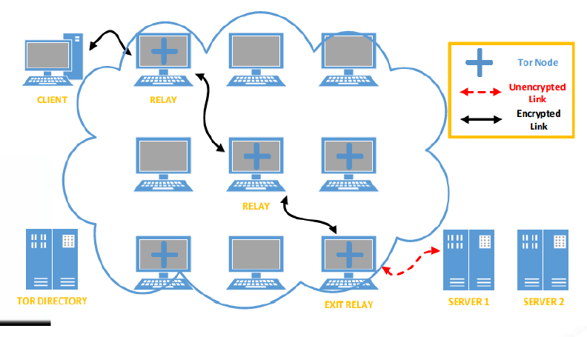

**TOR enhancement over previous onion routing**

* **Many TCP streams can share one Circuit**
* **Congestion Control**
* **Directory Servers**
* **End To End Integrity Checking**
* **Hidden Services via Rendezvous Points**

**Attacks on TOR**

* **Active attacks**
* **Passive attacks**

**Deep & Dark web**

* **DEEP WEB: This is a sub-set of the internet that cannot be indexed (found) by search engines like Google.**
* **DARK WEB: sub-set of the Deep Web that contains all sorts of websites, both legal and illegal.**

**Arrest and trial of Ross Ulbricht**